Assignment-19.3:

Task 8: Write a MapReduce program that takes the output of Task 5 (refer session 7, assignment 1) as input, and produce output which is sorted on the total units sold. You may use a single reducer for the sorting. Use Sequence File formats as an output of Task 5 and as input for this task

Driver Class:

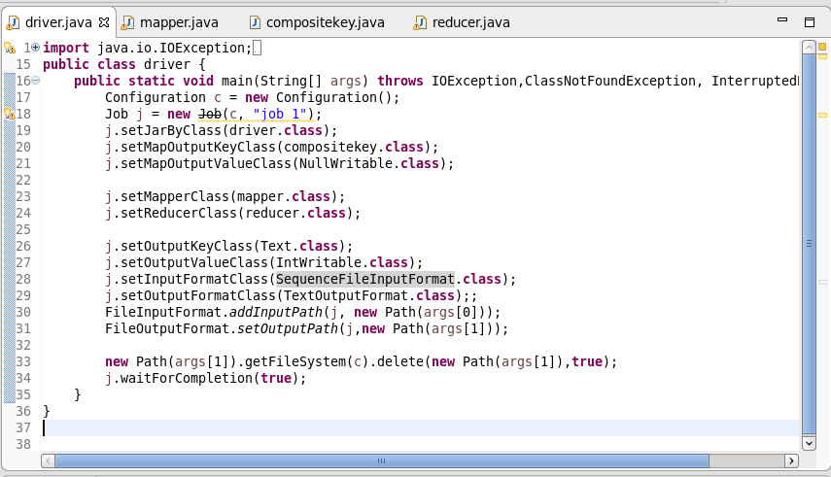

Mapper Class:

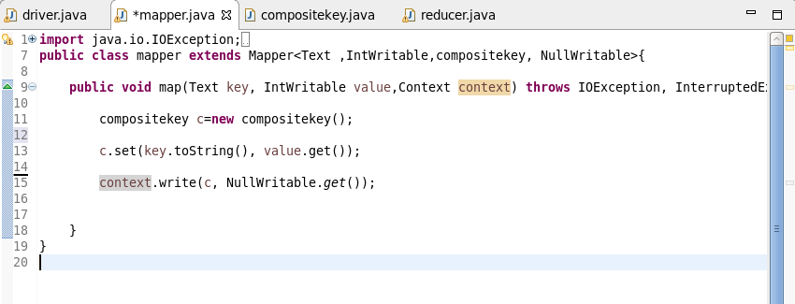

Composite key Class:

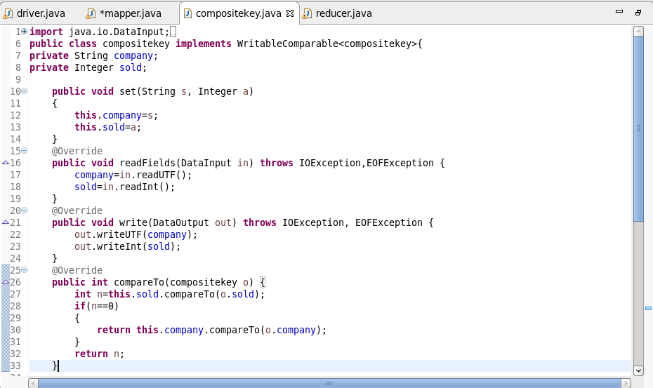

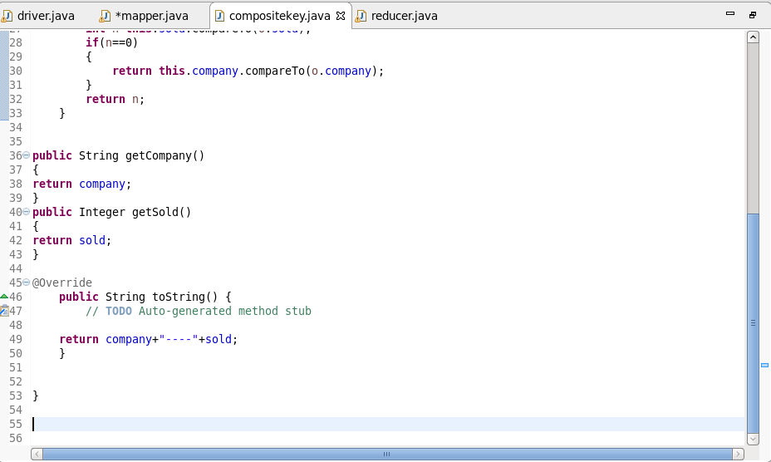

Reducer Class:

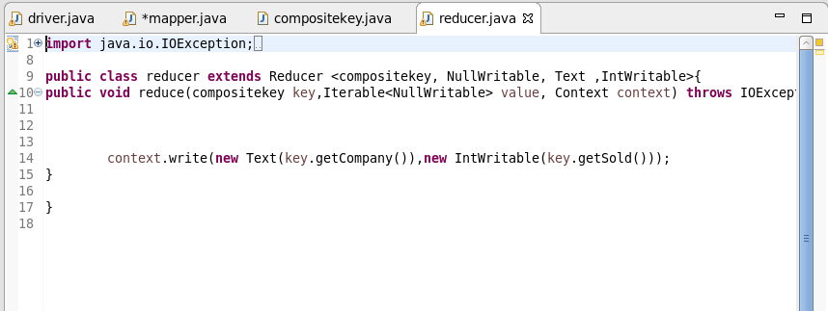

Input File:

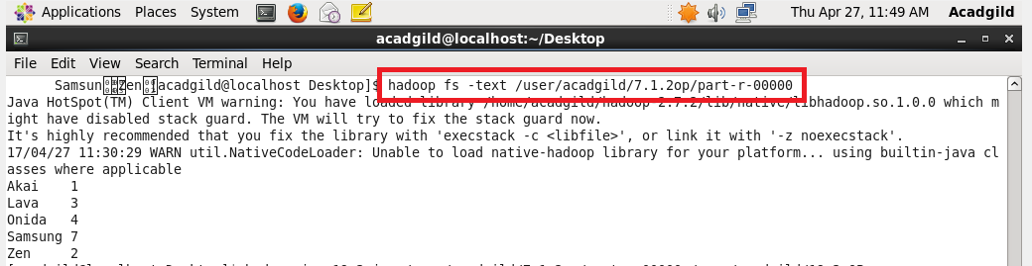

Running the Jar File:

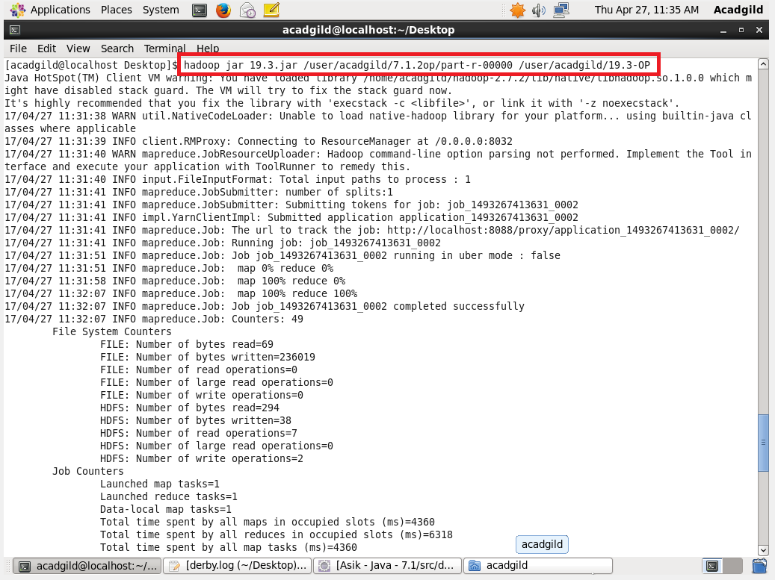

Output:

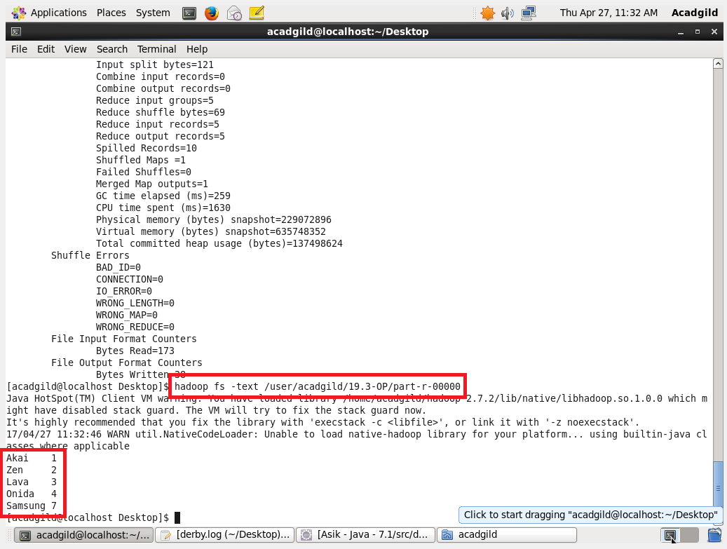

In the Output, we can see that the output is sorted based on the total units sold.